Toshiba CT - Image Quality Sheet – Clarification

Created by Brian Weindling 12/17/14

Section 1 – CT Number Accuracy
TOS phantom Field m 4x4 2-stack, 120v, 300ma 1 Sec, FC70
Ma | Air(A) | Delron(B) | Acrylic(C) | Nylon(D)
Result 1100
Result 0011
Tolerance | -975 to -1015 | 330 to 350 | 120 to 140 | 90 to 110

Phantom to Use: Use the “Tos” or “Toshiba” phantom seen below.
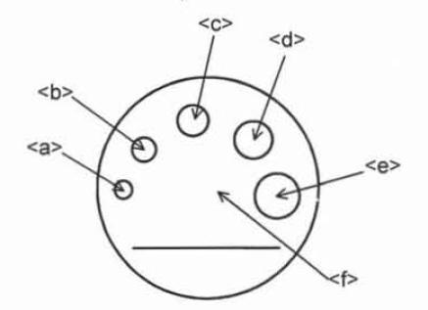
Required Measurements: Use the “measure tool” to place a circular 25 pixel circular ROI (that should just about fill circle A) in each of the desired locations. The mean CT number should be recorded in the table. If the value is in spec then the field will highlight green.

Additional Info: You should be creating two images with one exposure (4mm x 4 slices, with two of each image stacked together). The data from the first image is recorded along the “Result 1100” row of the table and the data from the second image created is recorded along the “Result 0011” row of the table. This is a throwback to how the Aquilion 4 slices designated the images acquired.

Section 2 – Noise and CT Number Check
PP Water Phantoms | 4x4 2 stack 120kv 300mA 1sec, FC70
Data/field Size | Mean1100 | Mean 0011 | mean specs | SD 1100 | SD 0011 | SD specs
LL |  |  | -111+/- 9.5 |  |  | 46 +/- 7.5
L |  |  | -111+/- 9.5 |  |  | 16.5 +/- 5
M |  |  | 0 +/- 3 |  |  | 14.0 +/- 2.8
S |  |  | 0 +/- 3 |  |  | 6.5 +/- 1.3
SS |  |  | 0 +/- 3 |  |  | 3.7 +/- 0.7

Phantom to Use: For each row of the table you will use the corresponding phantom. For example, for the top row of the table you will shoot the LL (large large) 500mm polypropylene phantom in the LL field of view. Note that the LL and L phantom are polypropylene. The M phantom is water and the S and SS phantom are a combined water phantom.

Required Measurement: For each phantom you should take one exposure (two images) and use a 250 x 250 pixel box to measure the middle of each image. Record the mean on the left side of the table and the standard deviation on the right side of the table. If the values are in spec the box will highlight green.

Section 3 – Uniformity Check
M field 4x4 2-stack.120KV 300mA 1Sec FC 70 |  |  |  |  | Uniformity
Medium Fov | Top | Center | Bottom | Left | Right | Max Diff.
Spec 0 +/-3

Phantom to Use: For this test use the medium water phantom. You may make the measurements on the same medium field shot from section 2 if you like.

Required Measurement: Place a 25 pixel circular ROI at each required section. The “max diff” is the difference between the highest and lowest of all the values.

Addition Notes: When placing the outer ROI circles be sure to leave at least a half circles distance from the edge of the image. If the ROI is too close to the edge of the image then the CT numbers will be skewed.

Section 4 – Low Contrast Resolution
Resolution Phantom (DCHLCT) S field,4x4 2-stack, 120Kv 320 mA 1 sec, FC41
 |  |  |  | Low contrast Resolution
Results | Mean 1 |  | 0 | (M1-M2)/10*.3*#ROW=
Spec | Mean 2
# of the row clear | in 3 %

Phantom to Use: Use the Utra-Cal phantom for this test. Each system comes with this phantom. The phantom is small and has two parts. The larger section with water in it has a plastic disk inside that has many holes punched out of it. The smaller “hockey puck” section is on the front and has small pins imbedded in it.

Required Measurements: Align the phantom so the exposure will be of the plastic disk in the middle of the phantom. Of the two images created only one will display the plastic disk well due to its small thickness; use this image. Use a small circular ROI to measure the mean at the two locations in red (see picture below). Each wedge of the phantom contains 4 rows of holes of decreasing size. The “# of the row clear” is the number of rows of holes seen in the wedge at the six o’clock position. For example if the three largest rows of holes can be seen but the smallest cannot be seen then the number of rows is 3. In the example picture all of the holes can be seen (see the arrow for location). Thus in the picture the “# of the row clear” is equal to 4.

Additional Notes: If you do not see plastic or its holes try adjusting the location of the phantom. If it is too far forward or backward the disk will be missed. Also, if the phantom is skewed in the holder and thus not parallel to the scanner then the disk will not be fully in the x-ray beam field and will not be totally visible. Lastly, try to adjust the WW and WL. In the example the WL is 9 and WW is 40 which is a good starting point.

The general rule of thumb is that the clearer the holes in the 6 o’clock portion of the phantom are, the better the low contrast resolution is. You should be able to see three or four rows of holes clearly where the red arrow is.

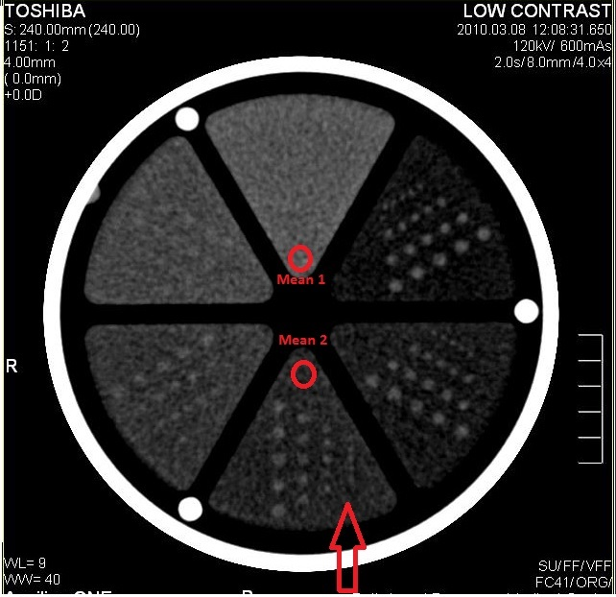

Section 5 – High Contrast Resolution
Resolution Phantom |  | S field 1x4 2-stack, 120Kv 200mA 1 sec FC30 and FC90 | High Contrast Resolution
Zoom Recon | Results | Min.Spec | Set WW to 1 Use Vari_Area 33mm from center of low contrast
FC30 |  | 0.55
FC90 |  | 0.35

Phantom to Use: Use the Utra-Cal phantom for this test. Each system comes with this phantom. The phantom is small and has two parts. The larger section with water in it has a plastic disk inside that has many holes punched out of it. The smaller “hockey puck” section is on the front and has small pins imbedded in it.

Required Measurements: The pins in this section of the phantom begin at 0.80mm and decrease by 0.05mm with each smaller section. Most phantoms have 10 lines of pins but some newer have 11. Set the WW to 1 then slowly change the WL until the pins come into view. As you change the WL you will see the pins separate and then blend back together. Select the WL where the smallest pins are visible as individual circles; that row corresponds to the systems high contrast resolution. So, on the picture below the high contrast resolution is 0.35mm because that is the smallest row where all the pins are visible and not blended together.

Additional Notes: This scan must be acquired in the Small calibrated field of view, but zooming in using the vari area tool and creating another exposure will increase your image quality and provide a better contrast number.

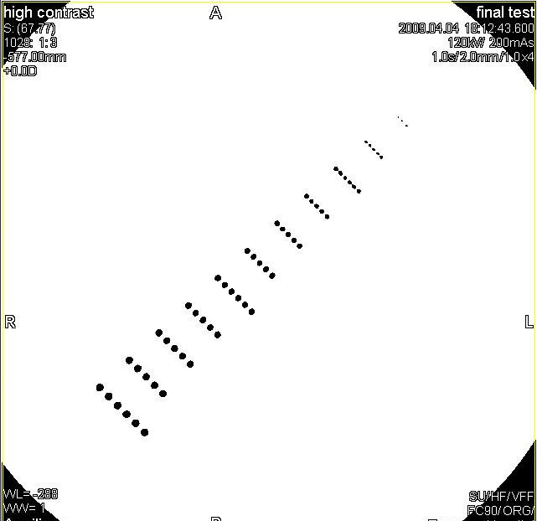
0.55mm
0.35mm
0.8mmm

Section Six – Contrast Scale

Contrast Water Phantom filed S, 4x4 2-stack, 120kv, 300mA 1sec,FC70,ROI 50x50 |  |  |  |  | Contrast Scale
Results |  | Spec | 125+-5
Phantom to Use: Use the front portion of the step wedge phantom for this test. This phantom has three metal ramps in the water section. The front section of the phantom has an acrylic circle in the middle.

Required Measurement: Measure the mean value of the acrylic portion of the phantom with a 50 x 50 pixel ROI. Next measure the water only portion of this phantom with the same ROI. The difference between these two measurements is the result.

Section Seven – Laser and Table Accuracy

After table is Incremented 30MM:
 |  |  |  | Laser alignment
Laser Pos on Ruler | 0 mm | Laser Pos on Ruler | 30 mm
Digital Table Indicator | 0 mm | Digital Table Indicator
Laser Pos on Ruler | -30 | Laser Pos on Ruler | 0 mm
Digital Table Indicator |  | Digital Table Indicator

Phantom to Use: no phantom, just a ruler or tape measure.

Required Measurement: Place a ruler or tape measure on the table perpendicular to the gantry. Set the outside laser lights to 0mm on the ruler and 0mm for table position. Move the table so the laser light is on the 30mm mark of the ruler. Record the value of the table position; it should be very close to 30mm. Next move the table so the laser light is at the 0mm position on the ruler and then at the -30mm position on the ruler. Record the readout of the table position for each movement.

Addition Notes: This test is not in the manufacture manuals but is required by some states to pass inspection

Section Eight – Slice Thickness
 |  |  |  | Slice Thickness
Technique 120KV 300mA 1sec, FC 70, No Stack
Slice | Format | Specs | CT# AL | CT# of Water | Calc'd WL | Measured Results
1 | 1 mmx4 | 0.8 to 1.5 | 900 | 12.8 | 456.4
2 | 2 mmx4 | 1.8 to 2.5 | 680 | 15.9 | 347.95
3 | 3 mmx4 | 2.7 to 3.5 | 517 | 8.8 | 262.9
4 | 4 mmx4 | 3.6 to 4.4 | 404 | 9.2 | 206.6
5 | 5 mmx4 | 4.5 to 5.5 | This is for 4 slice only
6 | 6 mmx4 | 5.4 to 6.6 | 271 | 7.4 | 139.2
8 | 8 mmx4 | 7.2 to 8.8 | 203 | 9.1 | 106.05

Phantom to Use: Use the wedge section of the step wedge phantom for this test. This phantom has three metal wedges/ramps in the water section. The front section of the phantom has an acrylic circle in the middle.

Result to Measure: Make an acquisition centered on the middle of the wedges/ramps. Choose one of the middle slices, set WW = 1. Increase the WL till the last bit of the wedge disappears. Take half of that WL number; use the resulting number as the new WL (Calc’d WL). Now use the measure tool to measure the wedge (vertical measurement), this measurement will be the slice thickness to record.

Additional Notes: A separate exposure must be made for each of the slice thicknesses in the table. Due to the limits of the measure tool you may need to just “do the best you can” when measuring the slice thickness.

